EXP NO: 12 Forensic Imaging NAME : ADHIYAN PERIYAR R P

DATE: 11/09/2025 ROLL NO : 231901002

AIM :

Learn the basic concepts of forensic imaging.

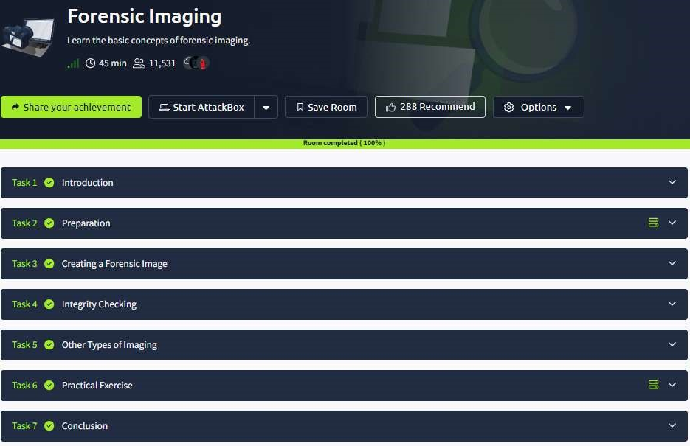

Task 1 : Introduction



Task 2 : Preparation

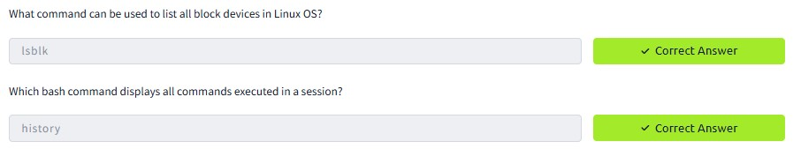

Task 3 : Creating a Forensic Image



Task 4 : Integrity Checking



Task 5 : Other Types of Imaging



Task 6 : Practical Exercise

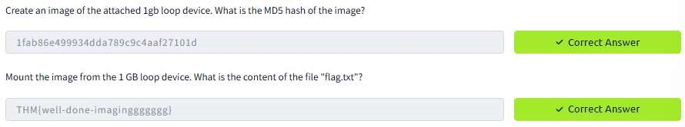

RESULT :

Forensic Imaging is successfully completed in tryhackme platform.